Title:

RETAIL SALES ANALYTICS & CUSTOMER SEGMENTATION

(A Data-Driven Decision Support System for Retail Optimization)

Submitted by:
- K. Likhita – 24BCD7226
- V. Jyothsna – 24BCD7240

Under the Guidance of Prof:

Gosala Bethany

Department of Computer Science Engineering

Course:

Data Mining and Data Warehousing

Academic Year:

2025–2026

ACKNOWLEDGEMENT
We would like to express our sincere gratitude to our project guide and faculty members for their valuable guidance, continuous support, and encouragement throughout the development of this project.
We are thankful to the Department of Computer Science Engineering and our institution for providing us with the opportunity and necessary resources to successfully complete this project on “Retail Sales Analytics & Customer Segmentation”.
We would also like to thank our classmates and friends for their suggestions and support during the implementation and testing phases of the project.
Finally, we express our heartfelt gratitude to our parents and family members for their constant motivation and encouragement throughout the completion of this work.

ABSTRACT
Retail businesses generate huge volumes of transactional and customer data every day. However, without proper analysis, organizations struggle to understand customer behavior, identify valuable customers, and predict customer churn. This project focuses on Retail Sales Analytics and Customer Segmentation using data mining and machine learning techniques to transform raw retail data into meaningful business insights.
The project uses an e-commerce retail dataset containing customer transactions, purchase quantity, invoice dates, and product pricing details. Data preprocessing techniques such as missing value removal, duplicate filtering, and feature engineering were applied to prepare a clean and reliable dataset. RFM (Recency, Frequency, Monetary) analysis was used to evaluate customer behavior patterns. K-Means clustering was applied for customer segmentation, while Random Forest Classification was used for churn prediction.
The project also includes visualization and dashboard analysis using graphs and Power BI to present business insights such as customer lifecycle analysis, sales trends, churn distribution, and revenue contribution by customer segments. The system acts as a decision support system that helps businesses improve customer retention, optimize marketing strategies, and maximize revenue.

CONTENTS
S.no | Description | Pg. No.
1 | Introduction | 6
2 | Problem Statement | 7
3 | Objectives | 7
4 | Dataset Description | 8
5 | Data Preprocessing | 8
6 | Methodology, Tools and Technologies | 9-10
7 | Machine Learning Concepts Used | 10
8 | Models Used and Justification | 11
9 | System Architecture | 12
10 | Implementation Workflow | 13
11 | Machine Learning Model Implementation and Results | 14-16
12 | Results and Discussion | 17
13 | Graph Analysis and Insights | 18-22
14 | Dashboard Results | 23
15 | Business Impact | 24
16 | Advantages | 24
17 | Limitations | 24
18 | Future Scope | 25
19 | Work Distribution | 25-26
20 | Conclusion | 26
21 | References | 26

List of Figures
S.no | Description | Pg.no
1 | Fig. 1. Customer Segmentation using KMeans | 15
2 | Fig. 2. Customer Segmentation Graph | 18
3 | Fig. 3. Customer Lifecycle Graph | 19
4 | Fig. 4. Churn Distribution Graph | 20
5 | Fig. 5. Sales Trend Graph | 21
6 | Fig. 6. Revenue by Segment Graph | 22

1. INTRODUCTION
In today’s digital era, retail businesses generate enormous amounts of customer and transaction data through online and offline sales systems. This data contains valuable information regarding customer purchasing behavior, spending patterns, and engagement levels. However, many organizations fail to effectively analyze this data, leading to poor customer understanding and inefficient marketing strategies.
Customer retention has become one of the most critical aspects of modern retail businesses. Retaining existing customers is more cost-effective than acquiring new customers. Therefore, businesses need systems that can identify high-value customers, detect at-risk customers, and provide personalized recommendations.
This project focuses on applying data mining and machine learning techniques to analyze customer behaviour using retail transaction data. Through customer segmentation, churn prediction, and dashboard visualization, the system helps businesses make data-driven decisions.

2. PROBLEM STATEMENT
Retail businesses generate large volumes of transaction data, but many organizations are unable to utilize this data effectively. Common challenges include:
- Poor customer understanding
- Generic marketing strategies
- Lack of customer segmentation
- Inability to identify churn risk
- No personalized business strategies
Due to these issues, businesses often experience reduced customer engagement and revenue loss.
The main objective of this project is to transform raw retail data into meaningful insights and actionable business strategies using data mining and machine learning techniques.

3. OBJECTIVES
The objectives of the project are:
- To analyze customer purchasing behavior using retail transaction data.
- To perform customer segmentation using clustering techniques.
- To identify high-value and at-risk customers.
- To predict customer churn using machine learning models.
- To provide actionable business insights.
- To develop an interactive dashboard for visualization.
- To improve customer retention and revenue optimization.

4. DATASET DESCRIPTION
The project uses an E-commerce Retail Dataset containing real-world transactional information.

Dataset Features
Feature | Description
Customer ID | Unique customer identifier
Invoice Date | Date of transaction
Quantity | Number of products purchased
Unit Price | Price of each product
Total Price | Total transaction amount
The dataset contains thousands of customer transactions that are used to analyze customer behavior patterns.

5. DATA PREPROCESSING
Data preprocessing is one of the most important stages in the project because machine learning models require clean and reliable data.

Steps Performed

5.1 Missing Value Removal
Rows containing missing customer information were removed.

5.2 Invalid Transaction Removal
Transactions with negative or zero quantity values were filtered.

5.3 Duplicate Removal
Duplicate records were removed to improve data quality.

5.4 Feature Engineering
A new feature called Total Price was created:
Total Price = Quantity × Unit Price

5.5 Date Conversion
Invoice date was converted into datetime format for time-based analysis.

6. METHODOLOGY, TOOLS AND TECHNOLOGIES
The project follows a structured pipeline:

Step 1: Data Collection
The retail dataset was collected and loaded using Python libraries.

Step 2: Data Cleaning
Missing values, duplicates, and invalid transactions were removed.

Step 3: Exploratory Data Analysis (EDA)
Sales trends, customer behavior, and revenue patterns were analyzed using graphs.

Step 4: RFM Analysis
RFM Analysis was used to evaluate customer behavior.

Recency: Measures how recently a customer made a purchase.

Frequency: Measures how often a customer purchases.

Monetary: Measures how much money a customer spends.

Step 5: Customer Segmentation using K-Means
Customers were grouped into clusters based on behavioral similarity.

Step 6: Churn Prediction using Random Forest
A Random Forest classifier was used to identify customers likely to churn.

Step 7: Dashboard Visualization
Power BI and Streamlit dashboards were used for visual representation of insights.

Tools & Technologies Used
- Python (Pandas, NumPy, Scikit-learn)
- Jupyter Notebook
- Power BI
- Seaborn
- Excel

7. MACHINE LEARNING CONCEPTS USED

7.1 Supervised Learning
Used for churn prediction because labeled output data was available.

7.2 Unsupervised Learning
Used for customer segmentation because no predefined labels were available.

7.3 Clustering
K-Means clustering grouped similar customers together.

7.4 Classification
Random Forest classification predicted churn categories.

7.5 Feature Engineering
New features such as Average Purchase and Value Score were created.

7.6 Feature Scaling
StandardScaler was applied before K-Means clustering to normalize data.

7.7 Model Evaluation
Accuracy score and confusion matrix were used to evaluate model performance.
8. MODELS USED AND JUSTIFICATION

8.1 RFM Analysis

Why Used?
RFM analysis helps identify customer value and purchasing behavior.

Benefits
- Identifies loyal customers
- Detects inactive customers
- Supports targeted marketing

8.2 K-Means Clustering

Why Used?
K-Means clustering groups customers based on similar behavior.

Advantages
- No labeled data required
- Simple and efficient
- Useful for customer segmentation

8.3 Random Forest Classifier

Why Used?
Random Forest was selected because:
- High accuracy
- Reduces overfitting
- Handles complex data patterns
- Works well with tabular data
- Provides probability outputs
9. SYSTEM ARCHITECTURE
The project architecture follows the flow below:
Dataset Collection
↓
Data Cleaning
↓
Feature Engineering
↓
RFM Analysis
↓
K-Means Clustering
↓
Random Forest Churn Prediction
↓
Visualization & Insights
↓
Business Decision Support

10. IMPLEMENTATION WORKFLOW
The project implementation was carried out completely using Python in Jupyter Notebook. The workflow followed in the notebook is listed below:
- Import Libraries
- Load Dataset
- Data Overview
- Data Cleaning
- Feature Engineering
- RFM Calculation
- RFM Summary
- Feature Scaling
- K-Means Clustering
- Segment Labeling
- Churn Creation
- Customer Lifecycle Analysis
- Random Forest Machine Learning Model
- Model Evaluation
- Customer Segmentation Visualization
- Churn Visualization
- Customer Lifecycle Visualization
- Sales Trend Analysis
- Revenue by Segment Analysis
- Business Metrics Analysis
- Final Output Table Generation
- Excel Export and Dashboard Visualization
The final processed dataset was exported to Excel and further visualized using Power BI and Streamlit dashboards.

11. ML MODEL IMPLEMENTATION AND RESULTS

11.1 Customer Segmentation using K-Means
K-Means clustering was applied on the RFM features after feature scaling using StandardScaler. The objective of clustering was to group customers with similar purchasing behavior into meaningful business segments.

Features Used for Clustering
- Recency
- Frequency
- Monetary

Why Feature Scaling Was Used
The ranges of Recency, Frequency, and Monetary values are different. Since K-Means is a distance-based algorithm, StandardScaler was applied to normalize the data and ensure equal importance for all features.

Cluster Interpretation
After clustering, the customer groups were interpreted based on average RFM values:
Segment | Characteristics
High Value | High spending and frequent purchases
Regular | Moderate spending and activity
At Risk | Low engagement and high recency

K-Means Result
The clustering process successfully grouped customers into meaningful categories, enabling better customer understanding and personalized business strategies.

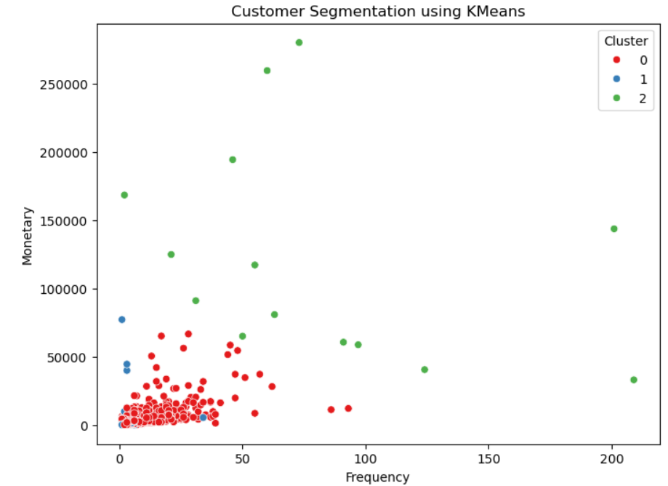

Fig. 1.Customer Segmentation using KMeans

11.2 Churn Prediction using Random Forest Classifier
A Random Forest Classifier was used to predict customer churn. Customers with Recency greater than 90 days were labeled as churn customers.

Why Random Forest Was Used
Random Forest was selected because:
- It provides high accuracy
- Reduces overfitting
- Handles complex patterns effectively
- Works well with tabular datasets
- Generates probability-based outputs

Input Features Used
- Recency
- Frequency
- Monetary
- Average Purchase
- Value Score

Model Training Process
The dataset was divided into training and testing sets. The Random Forest model was trained using the training dataset and evaluated on the testing dataset.

Model Evaluation
The following evaluation metrics were used:
- Accuracy Score
- Confusion Matrix
- Churn Probability Prediction

Results
The Random Forest model achieved an accuracy of 92% and successfully identified customers likely to churn. Probability scores helped identify customers with high churn risk.

Business Impact of the Model
The churn prediction model helps businesses:
- Identify customers likely to leave
- Take preventive retention actions
- Improve customer engagement
- Reduce revenue loss

12. RESULTS AND DISCUSSION
The project successfully analyzed retail transaction data and generated meaningful business insights using data mining and machine learning techniques. Through customer segmentation, churn prediction, lifecycle analysis, and dashboard visualization, the system helped identify customer behavior patterns and business opportunities.

Key Results
- High-value customers were identified, contributing a significant portion of overall revenue.
- At-risk and inactive customers were successfully detected through lifecycle and churn analysis.
- The Random Forest model effectively predicted potential customer churn based on purchasing behavior.
- Customer segmentation using K-Means clustering grouped customers into meaningful behavioral categories.
- Sales trend analysis revealed fluctuations in customer demand over time.
- Interactive dashboards provided clear visualization of revenue, customer activity, churn distribution, and customer segments.

Business Outcome
The project enables businesses to:
- Understand customer purchasing behavior
- Improve customer retention strategies
- Detect churn risk at an early stage
- Perform targeted and personalized marketing
- Support data-driven business decision-making
Overall, the project demonstrates how retail data can be transformed into actionable insights that improve customer engagement and business performance.

13. GRAPH ANALYSIS AND INSIGHTS

13.1 Customer Segmentation Graph

Insight

Most customers belong to the Regular segment, while High-Value customers contribute a significant portion of total revenue.

Business Impact

Businesses should focus on retaining high-value customers through loyalty programs.

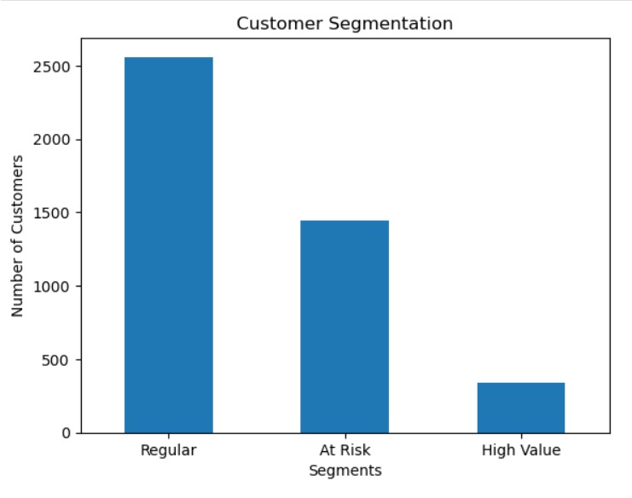

Fig. 2. Customer Segmentation Graph

13.2 Customer Lifecycle Graph

Insight

A large number of customers fall under Warm and Lost categories, indicating reduced customer engagement.

Business Impact

Businesses should implement re-engagement strategies and promotional campaigns.

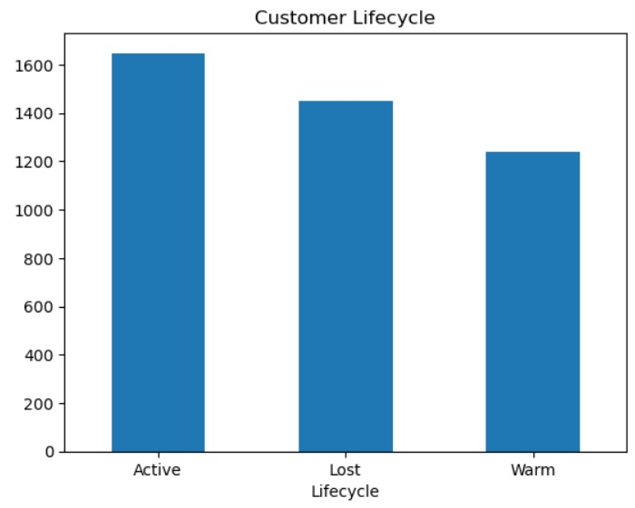

Fig. 3. Customer Lifecycle Graph

13.3 Churn Analysis Graph

Insight

A significant percentage of customers are at churn risk.

Business Impact

Early churn detection helps businesses improve retention.

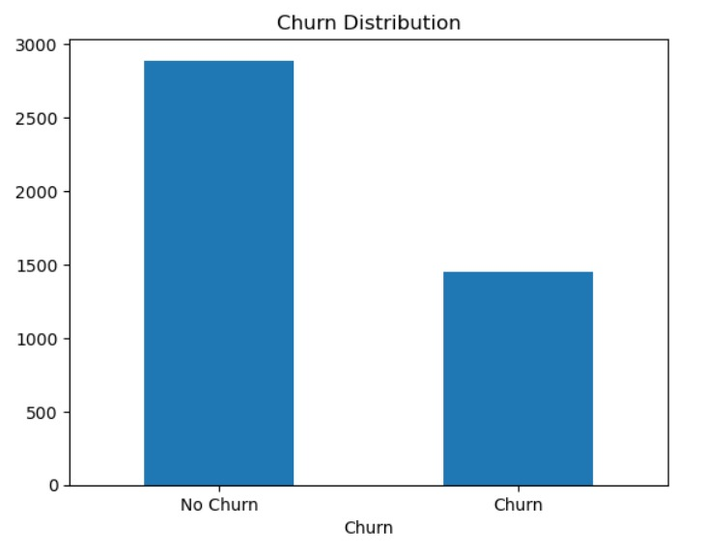

Fig. 4. Churn Distribution Graph

13.4 Sales Trend Graph

Insight

Sales fluctuate over time, showing varying customer demand patterns.

Business Impact

Businesses can optimize inventory and marketing strategies.

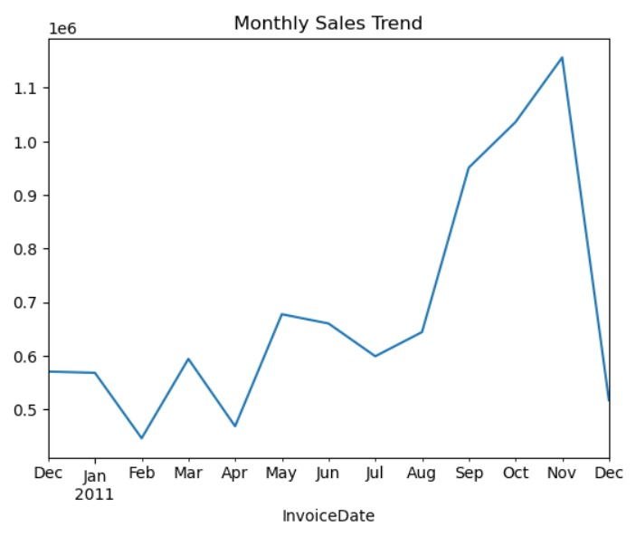

Fig. 5. Sales Trend Graph

13.5 Revenue by Segment Graph

Insight

Revenue distribution is uneven, with high-value customers generating the majority of revenue.

Business Impact

Personalized marketing strategies can improve profitability.

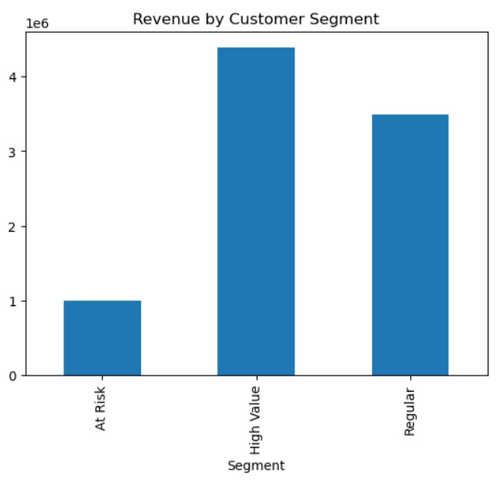

Fig. 6. Revenue by Segment Graph

14. Dashboard Results
The Power BI dashboard successfully visualized:
- Total Revenue
- Total Customers
- Customer Segments
- Churn Distribution
- Sales Trends
- RFM Analysis

Observation
The dashboard provided a complete overview of customer behavior and business performance.

Business Meaning
Businesses can use the dashboard for real-time monitoring and strategic decision-making.

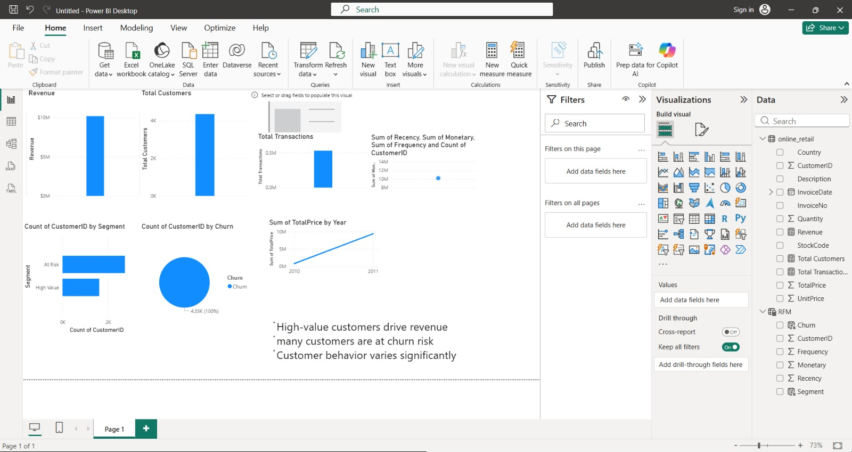 Fig. 7. PowerBI Dashboard

15. BUSINESS IMPACT
The project provides several business advantages:
- Better customer understanding
- Improved customer retention
- Personalized marketing
- Revenue optimization
- Data-driven decision making
- Early churn identification
The dashboard enables businesses to monitor customer behavior and make strategic decisions effectively.

16. ADVANTAGES
- Converts raw data into insights
- Helps identify valuable customers
- Detects churn risk early
- Supports personalized marketing
- Improves business decision-making
- Easy visualization through dashboards

17. LIMITATIONS
- The dataset used is static and does not reflect real-time customer behavior.
- Limited features were available, which may affect model accuracy.
- Churn was defined using a simple rule (Recency > 90 days), which may not capture all real-world scenarios.

18. FUTURE SCOPE
The project can be improved further through:
- Real-time dashboard integration
- XGBoost implementation
- Recommendation systems
- Deep learning models
- CRM integration
- Seasonal and festival sales prediction
- Cloud deployment
Future enhancements can make the system more scalable and industry-ready.

19. WORK DISTRIBUTION
The project work was distributed equally among the team members to ensure smooth execution and effective completion of all project tasks.

V. Jyothsna – 24BCD7240
- Performed data collection and preprocessing
- Conducted Exploratory Data Analysis (EDA)
- Created visualization graphs and interpreted insights
- Assisted in dashboard development using Power BI
- Prepared project presentation and final report formatting

K. Likhita – 24BCD7226
- Implemented RFM analysis and feature engineering
- Developed customer segmentation using K-Means clustering
- Implemented churn prediction using Random Forest Classifier
- Worked on customer lifecycle analysis and Streamlit integration
- Contributed to report preparation and documentation

Joint Contributions
Both team members collaboratively worked on:
- Problem identification and project planning
- Dataset analysis and understanding
- Business insight generation
- Model testing and validation
- Final project review and presentation

20. CONCLUSION
The project successfully applied data mining and machine learning techniques to analyze retail customer behavior. Through segmentation, churn prediction, and dashboard visualization, the system generated meaningful business insights that support better decision-making and customer retention strategies.

21. REFERENCES
- Scikit-learn Documentation – https://scikit-learn.org
- Pandas Documentation – https://pandas.pydata.org
- NumPy Documentation – https://numpy.org
- Streamlit Documentation – https://streamlit.io
- Power BI Documentation – https://powerbi.microsoft.com
- Kaggle Retail Dataset – https://www.kaggle.com

